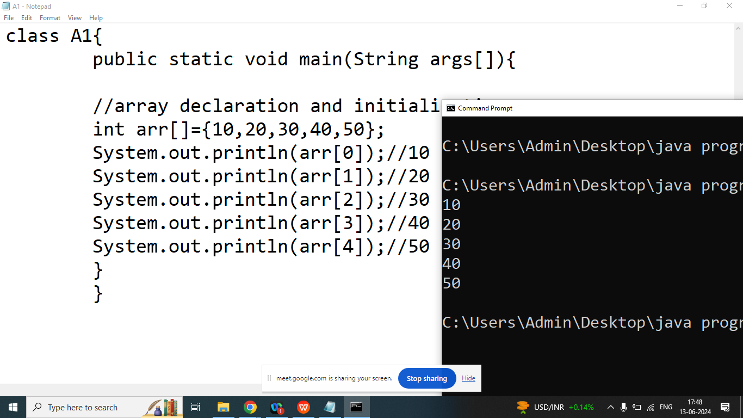

import java.util.Scanner;

class A1{

public static void main(String args[]){

//array declaration and initialization

int arr[]=new int[5];

Scanner sk=new Scanner(System.in);

System.out.println("Enter ELements of Index 0 : ");

arr[0]=sk.nextInt();

System.out.println("Enter ELements of Index 1 : ");

arr[1]=sk.nextInt();

System.out.println("Enter ELements of Index 2 : ");

arr[2]=sk.nextInt();

System.out.println("Enter ELements of Index 3 : ");

arr[3]=sk.nextInt();

System.out.println("Enter ELements of Index 4 : ");

arr[4]=sk.nextInt();

System.out.println(arr[0]);//10

System.out.println(arr[1]);//20

System.out.println(arr[2]);//30

System.out.println(arr[3]);//40

System.out.println(arr[4]);//50

}

}

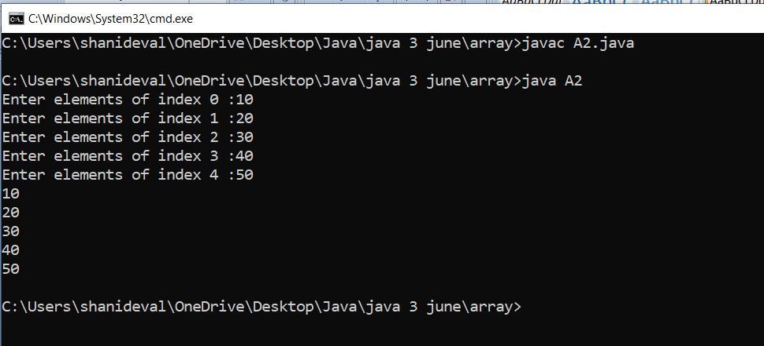

Q2. Explain length properties of the array

Ans: It will return size of the array or number of elements in the array

Syntax:

arrayName.length;

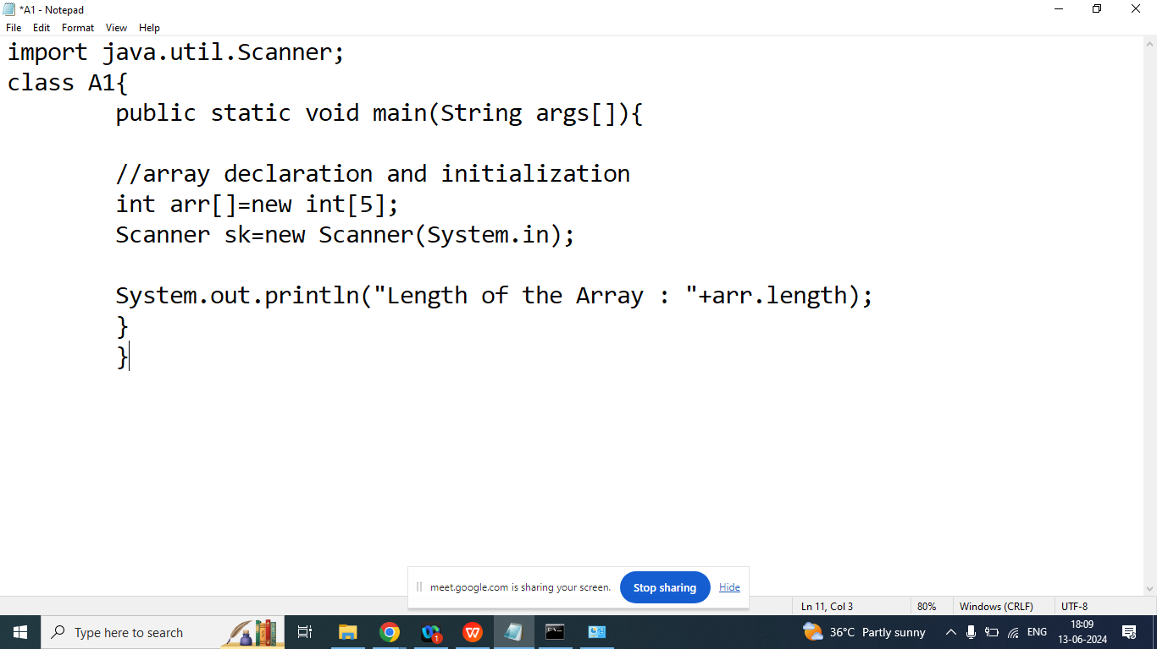

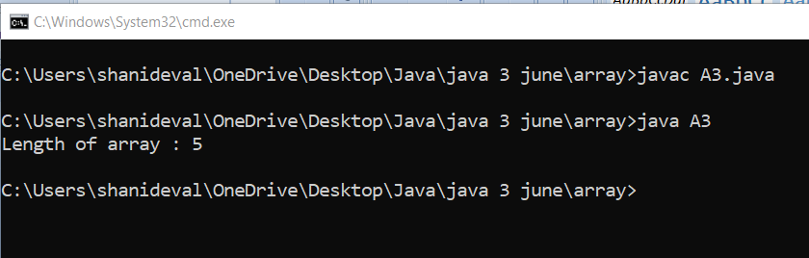

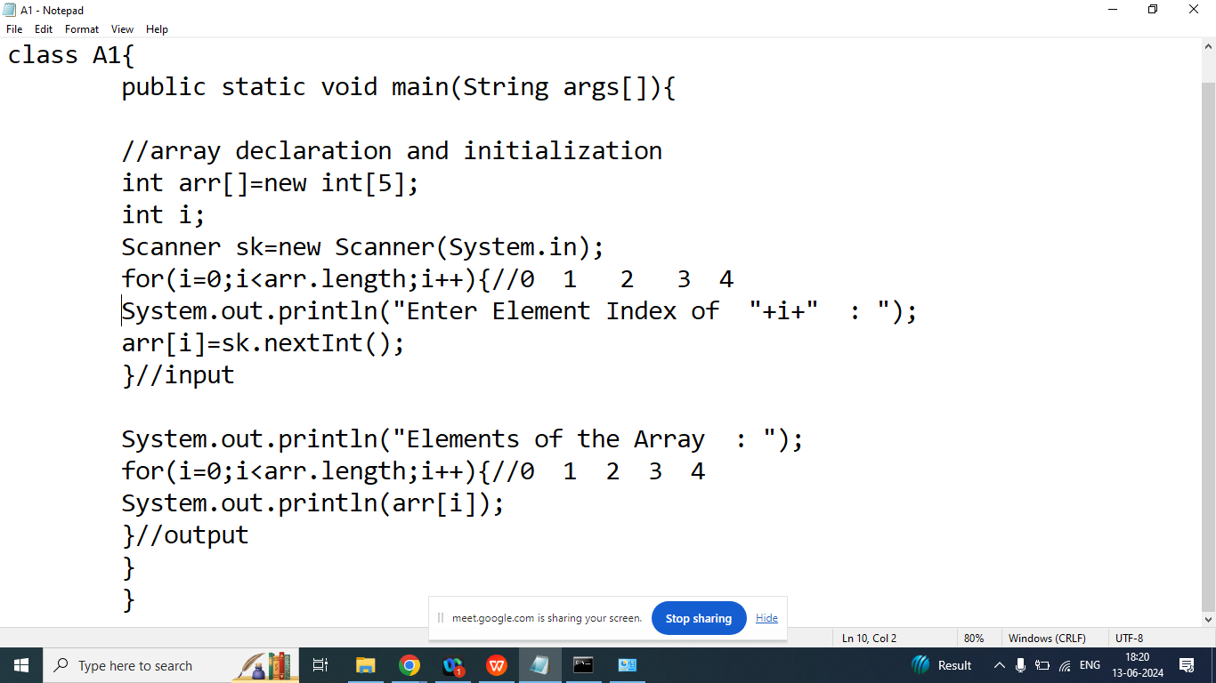

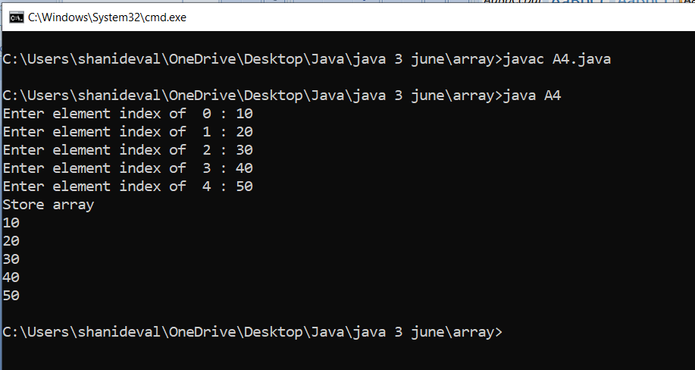

Q4. Write a java program to take 5 students name from the user and print its on the screen.

